Current Sensors

Abstract
This document illustrates the functions of current sensors in motor applications and available current sensors in the market, including the following parts
- Design Requirements
- Background Knowledge
- Comparison of the most popular current sensors
- Shunt resistor
- Hall Effect Current Sensors
- Possible Devices

1. Design Requirements
Parameter | Requirements
I_{m} (A) | 20
Frequency (Hz) | 700
PCB mounted | Yes
Non-Intrusive | YES
Possible Sensor Technology | Hall Effect

2. Background Knowledge ^{[1]}

2.1 Comparison of the most popular current sensors
The three most popular current sensors in motor control applications and their main features are listed below:
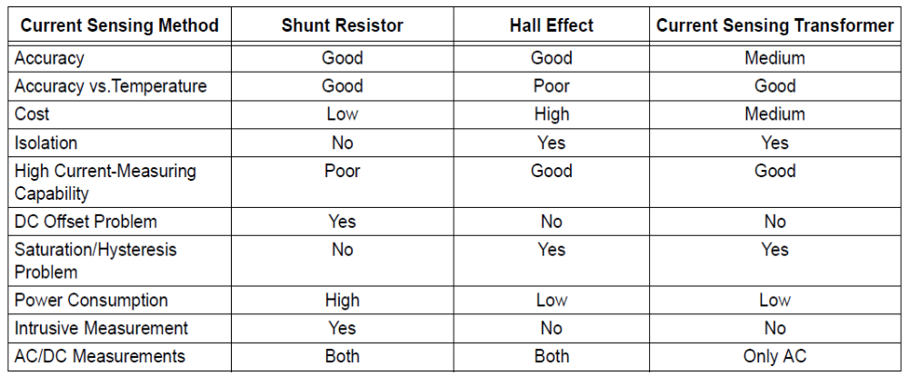

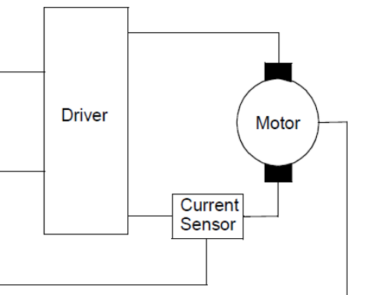

2.2 Shunt resistor
The typical schematic of a shunt resistor current sensor is shown below
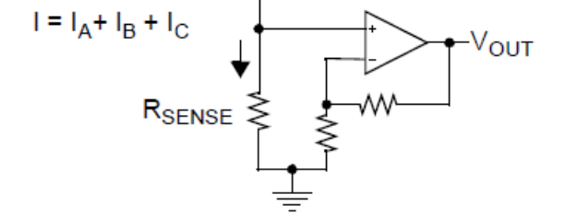

The voltage across Rsense, Vsense is amplified to Vout which is used to calculate the current across Rsense.
A large Rsense will have a larger Vsense, which makes error of the amplifier less significant. However, large Rsense causes two problems: 1) Higher dissipation 2) High EMI noises

High-Side vs. Low-Side Current Shunt Measurements
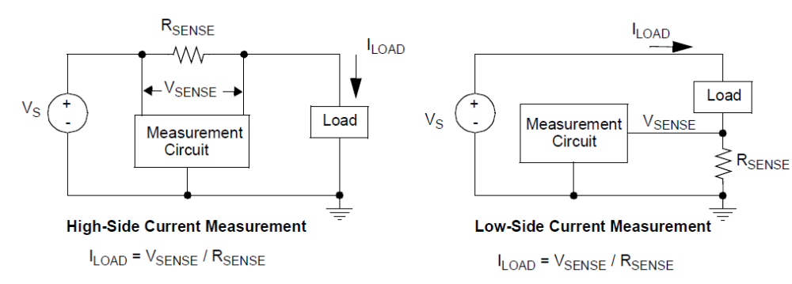

 | Advantages | Disadvantages
High-side | Less intrusive | Large Vsense + *
High-side | Can detect overcurrent faults | Requires a high-voltage amplifier **
High-side | Filter undesirable  noise
Low-side | Use low-voltage amplifier | Disrupts the ground path
Low-side | Use non-inverting amplifier | Additional noises
Low-side |  | Unable to detect a fault
* The positive side of Vsense is connected to Vs which may be too high for the amplifier.
**For voltage requirements beyond 60V, a current mirror circuit can be used to sense the current. A current mirror can be implemented with readily available, high-voltage transistors.

2.3 Hall Effect Current Sensors
The Hall Effect is based on the principle that a voltage (VH) is created when current (IC) flows in a direction perpendicular to a magnetic field (B),

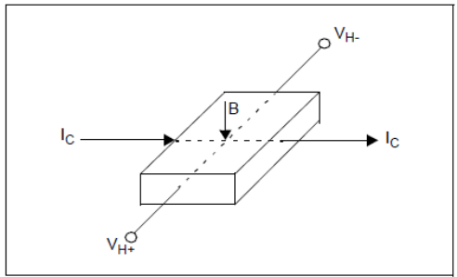

The Hall Effect current sensor can be placed on the PCB directly over the current trace that will be monitored. The sensor functions by measuring the magnetic flux that is created by the current flowing through the trace.
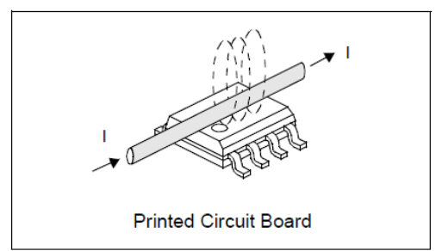

2.4 Current-Sensing Transformers
Current-sensing transformers provide galvanic isolation and can be used in high-current applications. The main disadvantage of current transformers is that an AC input signal is required to prevent the transformer from saturating.
The current sensing transformer is non-intrusive and relatively cheaper than Hall-effect sensors.
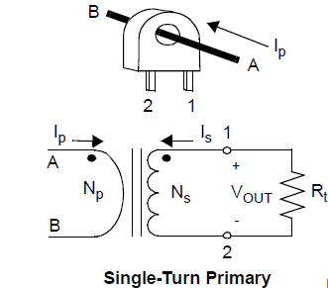

2.5 Discussion
With the aforementioned requirements, Hall Effect sensors seem to be the optimal choice. The main disadvantage of Hall Effect sensor is its higher price, which is not significant as the prices for current sensors are generally low.
Shunt resistor sensors can also be used. The additional noises may be problematic for low-side shunt resistor sensors but not for high-side ones with current mirrors.
Current sensing transforms are often for high-voltage AC applications, thus is not suitable for motor control.

3. Possible Devices

3.1 Allergro ACS711 Hall Effect Sensor IC
Parameter | Requirements
Sensitivity (mV/A) | 55
I_{m} (A) | 25
Frequency (kHz) | 100
PCB mounting | Yes
Max power dissipation (W) | 100 μΩ internal conductor resistance
Non-Intrusive | Yes
Price (USD) | 6.60
- Small package size, with easy mounting capability
- Overcurrent protection

3.2 Allergro ACS712 Hall Effect Sensor IC
Parameter | Requirements
Sensitivity (mV/A) | 66 - 185
I_{m} (A) | 5 - 30
Frequency (kHz) | 80
PCB mounting | Yes
Max power dissipation (W) | 100 μΩ internal conductor resistance
Non-Intrusive | Yes
Price (AUD) | 8.13
- Filter pin provides moderation filtration

3.3 LEM - LA 25-NP – Current Transducer
Parameter | Requirements
Accuracy | 0.5%
I_{m} (A) | 25, 36
Frequency (kHz) | 150
PCB mounting | Yes
Max power dissipation (W) | 25Ω internal conductor resistance
Non-Intrusive | Yes
Price (USD) | 23.33

3.4 CSM020GT5 Hall-effect Current Sensor Series
Parameter | Requirements
Accuracy | 0.7%
I_{m} (A) | 20
Frequency (kHz) | 200
PCB mounting | Yes
Max power dissipation (W) | 100Ω internal conductor resistance
Non-Intrusive | Yes
Price (USD) | 9.2
- CSM040GT5 has all the functions the others have but with the cheapest price.

Reference
[1] J. Lepkowski, Motor Control Sensor Feedback Circuits, Microchip, 2003

